CRYPT ARITHMETIC PROBLEM
Aim
To solve a Crypt Arithmetic problem using Python by assigning unique digits to letters such that the arithmetic equation is satisfied.
Objective
- To understand the concept of Crypt Arithmetic problems.
- To use Python to generate valid digit assignments.
- To ensure each letter is assigned a unique digit.
- To display the correct solution for the given puzzle.
Algorithm
- Start.
- Import the itertools module.
- Define the letters used in the crypt arithmetic puzzle.
- Generate all possible unique digit assignments.
- Assign digits to each letter.
- Ensure leading letters are not assigned zero.
- Convert the words into numbers.
- Check whether the arithmetic equation is satisfied.
- If a valid solution is found, display the mapping and stop.
- End.

Flow Chart
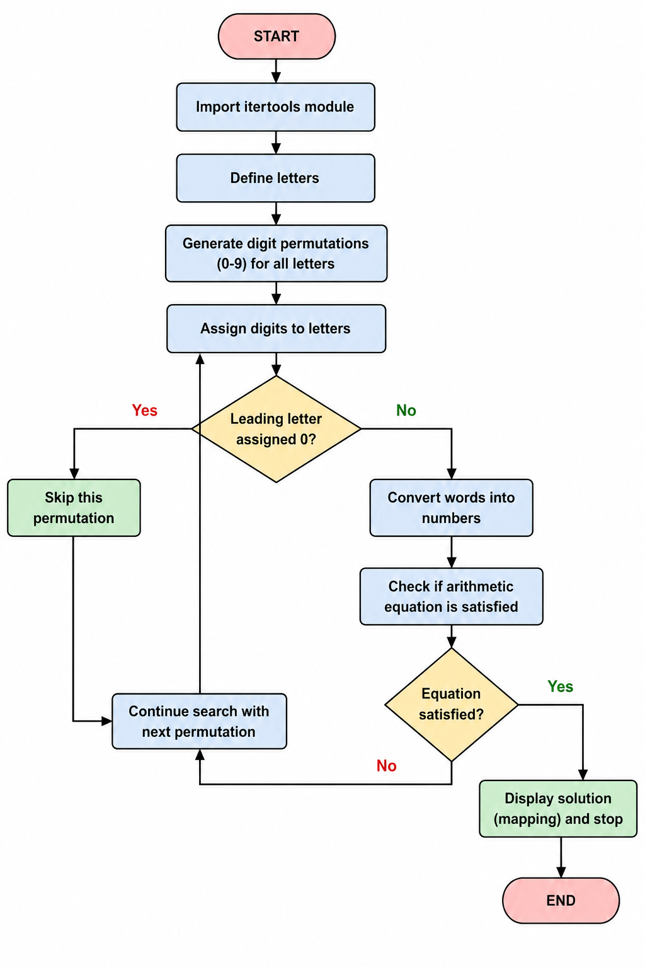
Code:
from itertools import permutations

for p in permutations(range(10), 8):
S,E,N,D,M,O,R,Y = p
if S and M:
send = 1000*S+100*E+10*N+D
more = 1000*M+100*O+10*R+E
money = 10000*M+1000*O+100*N+10*E+Y
if send + more == money:
print("SEND =", send)
print("MORE =", more)
print("MONEY =", money)
break
Output:
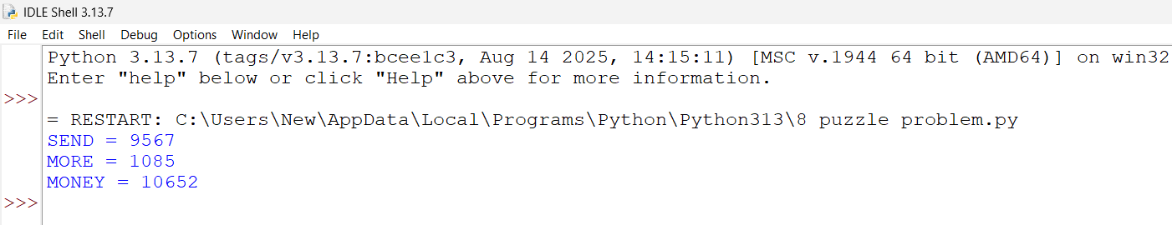
Result:
The Crypt Arithmetic problem was successfully solved using Python. The program assigned unique digits to each letter and verified the equation SEND + MORE = MONEY, producing the correct solution.

